La Cucina Italiana 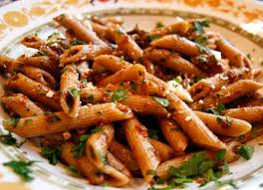
Secondo Piatti:
Fettuccine Alfredo: Fettuccine pasta, tossed with alfredo, and sauteed mushrooms, topped with parmesan.
Manicoti: 2 large tubes filled with ricotta, roasted garliq, fresh basil and
Spinach.
Ziti: Ziti tossed with sausage, fresh basil, blend of cheeses and fresh herbs
Cannelloni: Pasta tubes filled with beef, ricotta, spinach and parmesan,
topped with a champagne sauce.
Gnocchi: potato dumplings, sauteed with fresh basil, whole garlic, oregano, and a cream sauce.
Contorni:
Mozarella Caprese: fresh mozzarella with vine-ripened tomatoes
Antipasto: Penne Pasta, salami, pepperoni capicolla, red peppers, roasted roma tomatoes, kalamata olives, red onions and basil.
tuscan legume zuppa: lentils, beans, garbanzo, barley and vegetable stock.
Antipasti
Portobello ala Garliq: Portobello topped with sausage, basil, roasted roma tomatoes and cheese
Salsiccia peperoni ripieni: Fire grilled Jalapenos stuffed with premium sasauge
Un Dolce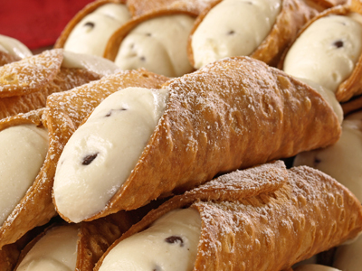
Cannoli: fried pastry dough, filled with a sweet creamy filling.
Gelato: italian ice cream in different flavors
Florentines: cookies with a touch of orange zest and almonds

Bevande
Lemonsoda: a carbonated lemon soft drink
Espressino: espresso and steamed milk with some cocoa powder on top.
Bombardino: 1/2 Advocaat or eggnog and 1/2 Brandy, It is served hot with whipped cream on top.
Acqua Vergine: pure drinking water

